**Bella Griffiths Database Practical Assessment – SQL Test.**

**Student ID: 11550147**

**1. Open and execute the script file ClientOrders.sql**

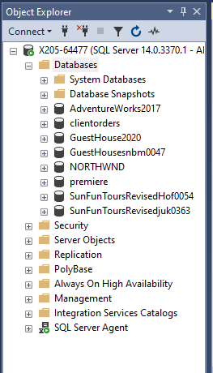

**2. List only those clients that live in Dunedin.**

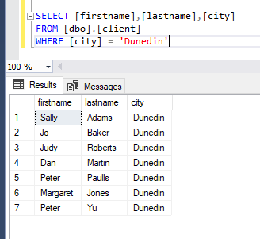

**3. List the clients whose last name begins with the letter J.**

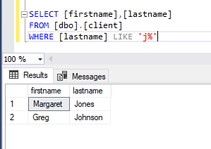

**4. Which clients have a balance between $50 and $150?**

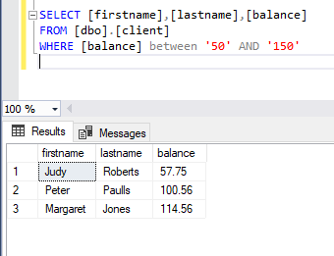

**5. What city does our client Mary Nelson live in?**

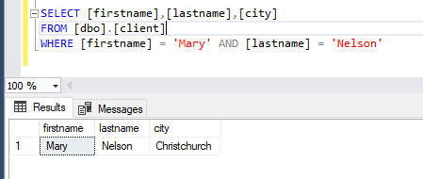

**6. Which clients have a balance below $200 and live in Dunedin?**

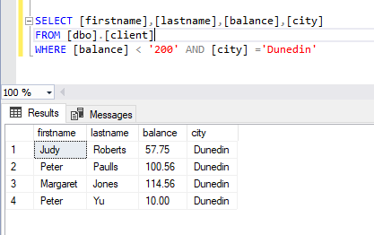

**7. What is the difference between the clients limit and their current balance for each client? (Hint: calculate the limit field minus the balance field). Name the field you create NewBalance.**

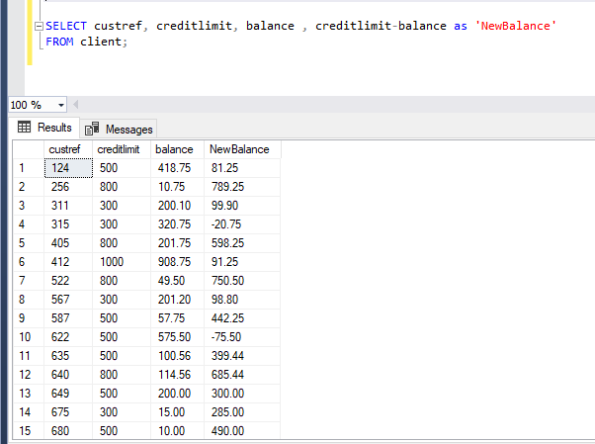

**8. What is the total price for each line of the order? (Hint: multiply the quantity by the quotedprice) Name the new field LineTotal.**

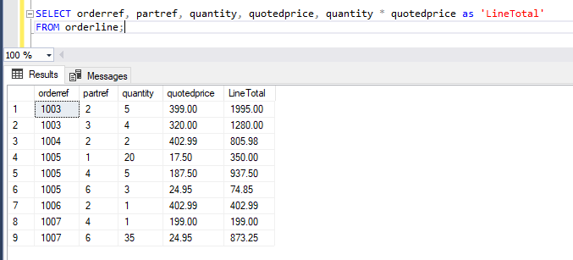

**9. Which client orders (Custorder) were place after 1/6/99?**

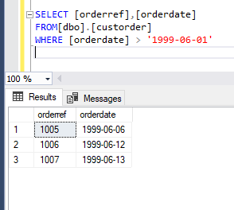

**10. How many clients live in each city where the number of clients is more than 3?**

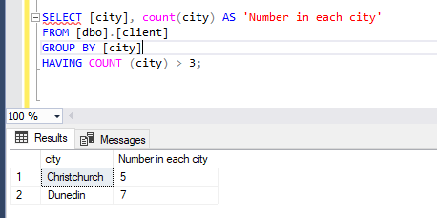

**11. What is the total balance for each sales rep?**

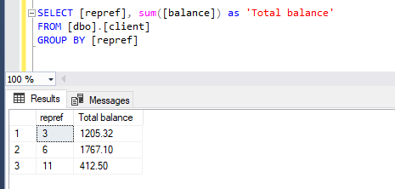

**12. What is the maximum balance for each city?**

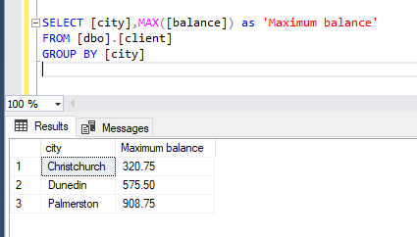

**13. List all of our clients and their client representatives (repref). Display the client name as one field, and the rep name as one field.**

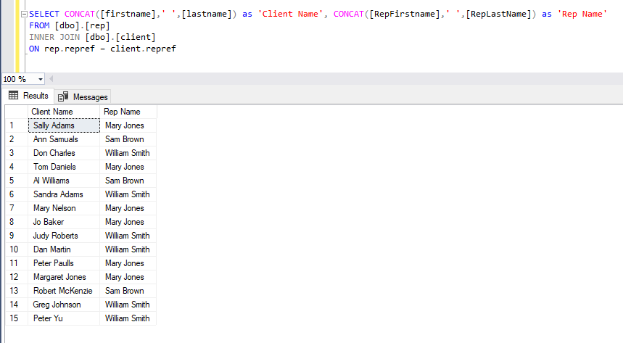

**14. List the first and last name of the clients next to their customer order (custorder) and include the date of the customers order.**

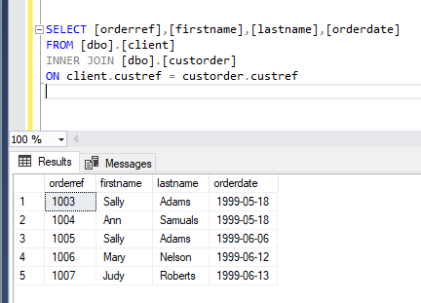

**15. What are the descriptions and amount on hand of the parts that appear on orderline 1007. Show only the records for 1007 in your answer?**

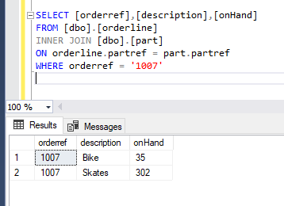

**16. List the description of the parts and their quoted price and quantity on each orderline. Sort by description.**

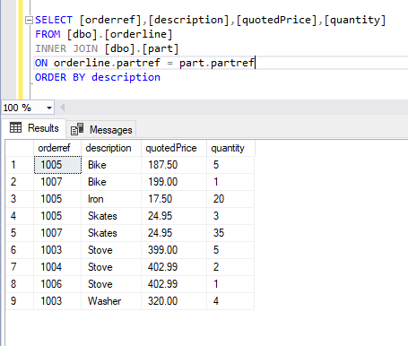

**17. List the description of the parts and their quoted price and quantity on each orderline. Only display the records that have a quoted price over 200.**

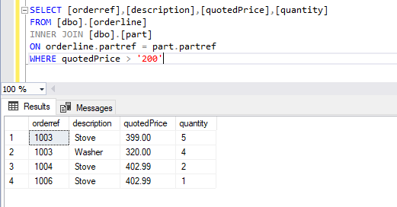

**18. List all orders (order ref, order date), the client name for those orders, and all part descriptions and unit prices.**

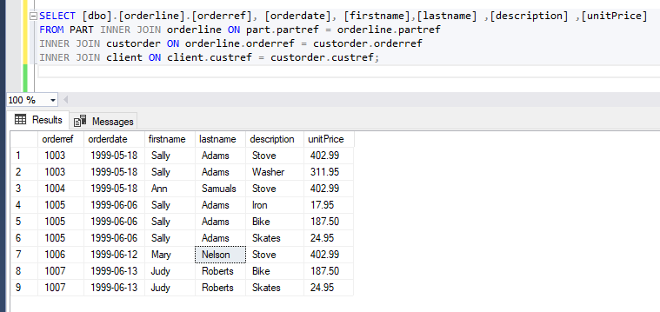

**19. List all orders (order ref, order date), the client name for those orders, and all part descriptions and unit prices. Display only the records where the order date is after 10/6/99.**

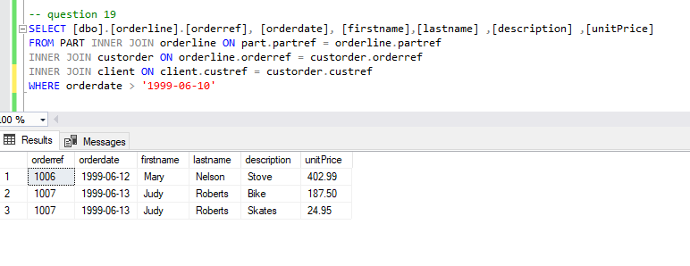

**20. List all orders (order ref, order date), the client name for those orders, the rep’s name, and all part descriptions.**

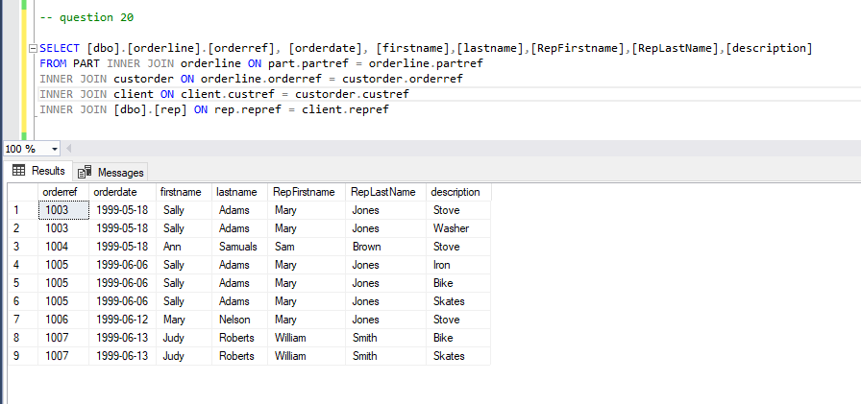

**21. What is the total balance for each sales rep. Display the rep name as one field.**

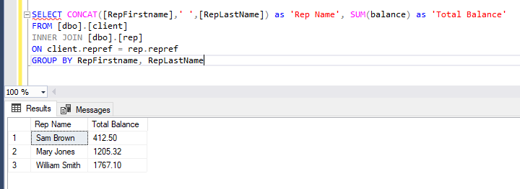

**22. Using the answer from Question 8, now display the total linetotal (sum of linetotal) for each Order (orderref).**

